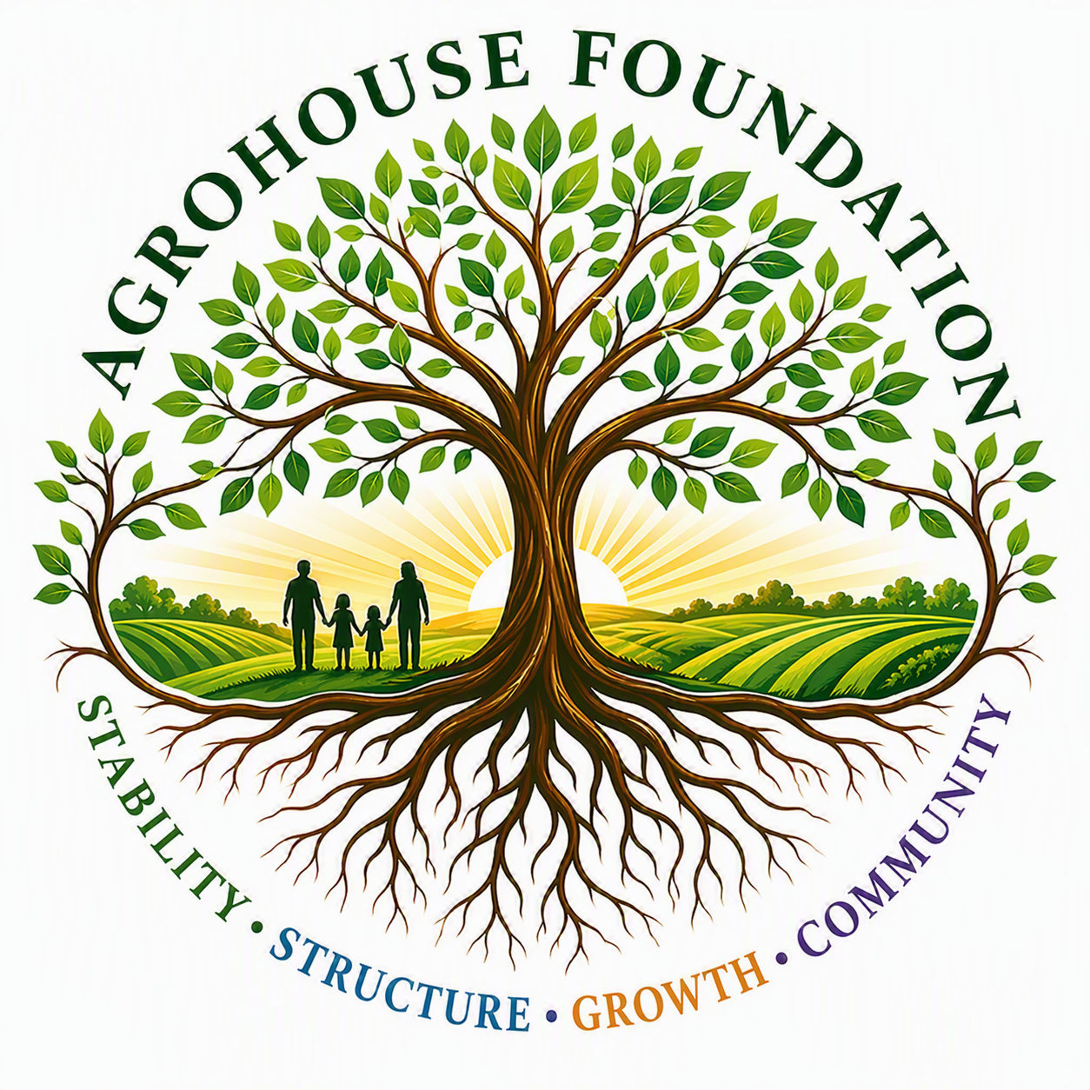
AGROHOUSE FOUNDATION
Community Stabilization · Sustainable Agriculture · Workforce Development · Vocational Housing
AGHF Inc., a Florida nonprofit corporation d/b/a AgroHouse Foundation
AgroHouse Foundation exists to strengthen communities through outreach stabilization, food security, sustainable agriculture, workforce development, and future vocational housing — building a phased, debt-free, grant-supported ecosystem that promotes long-term stability, self-sufficiency, and dignity.
125+  Individuals served weekly, and growing | 4  Integrated programs planned across the campus model | 75–100+  Acres targeted for a permanent campus site
Where We Are Now
• Program 1 (Community Outreach Stabilization) is in active development, supporting First Nazarene Church of Zephyrhills’ outreach — currently reaching an estimated 125 individuals per week and growing.
• Early-stage collaboration underway with Food and Fellowship on shared food security and volunteer engagement goals.
• Programs 2–4 (farm infrastructure, workforce development, and vocational housing) are in planning as future phases of a single integrated campus.
What We're Seeking
• Land opportunities — donation, legacy planning, or lease arrangements on 20–100+ acres suitable for a phased, multi-program campus
• Introductions to agricultural, food security, and workforce development leaders across Florida
• Guidance on relevant grants and funding pathways (agriculture, food security, workforce, infrastructure)
• Farm-to-school and school nutrition partnership pathways as agricultural production comes online
We would be grateful if you would keep AgroHouse Foundation in mind for property opportunities, agricultural partners, funding sources, or organizations whose mission aligns with ours.
Contact
Susan Slater  Treasurer, Board of Directors  Susan@AgroHouseFoundation.org  954-601-7209 | Maggie Baty  Founder, Chairperson & Executive Director  Maggie@AgroHouseFoundation.org  813-364-3921
Thank you for your time and consideration.

